**MINISTRY OF EDUCATION AND TRAINING**

**HCMC UNIVERSITY OF TECHNOLOGY AND EDUCATION**

**FACULTY FOR HIGH-QUALITY TRAINING**



Final Report

**IT Project**

Topic

**WEBSITE SALE MOTORCYCLES**

Course: IT project

Term 1 – School year: 2021-2022

Lecturer: Assoc. PhD. Hoang Van Dung

|  |  |
| --- | --- |
| **Student Name** | **Student ID** |
| Huỳnh Đình Thịnh | 20110404 |
| Hà Tấn Thọ | 20110405 |

*Thu Duc City, December 2nd, 2022*

**THANK YOU**

In order to successfully complete this topic and this report, we would like to extend our sincere thanks to our lecturer, Mr. Hoang Van Dung, who directly supported us throughout the process of making the topic. Thank you for giving us advices from his practical experience to guide us in the right direction with the requirements of the selected topic, always answer questions and give suggestions and corrections in time to help us overcome my shortcomings and complete the project on schedule.

We also would like to express our sincere thanks to the teachers in the High Quality Education Department in general and the Information Technology faculty in particular for their dedicated knowledge to help us gain a foundation to make this project. This topic has created conditions for us to learn and perform well on the topic. Along with that, we would like to thank our classmates for providing useful informations and knowledges to help us improve our report.

The topic and report are made by ourselves in a short time, with limited knowledge and many other limitations in terms of technicals and experiences in managing university. Therefore, in the process of creating this topic with shortcomings is inevitable, we look forward to receiving valuable comments from the teachers to make our knowledges more complete and we can do even better next time. We sincerely thank you.

At the end, we would like to wish all teachers staffs always having abundant health and more success in the career of teaching students. Once again we sincerely thank you.

**Score:** ............................................................................................................................

**Remark of teacher:**

...............................................................................................................................................................................................................................................................................................................................................................................................................................................................................................................................................................................................................................................................................................................................................................................................................................................................................................................................................................................................................................................................................................................................................................................................................................................................................................................................................................................................................................................................................

|  |
| --- |
| Thu Duc city, December 2nd, 2022 |
| **Signature and full name of teacher** |

Contents

Introduction 1

I. PROJECT DESCRIPTION 2

1. Project Reason 2

2. Objectives 2

3. System scope 3

4. Document Description 3

5. Project implementation plan 3

II. TASK ASSIGNMENT 5

III. DESCRIBE THE FUNCTIONALITY OF THE WEBSITE 6

1. Admin 6

2. Customer 7

2.1. Search product 7

2.2. Filter 8

2.3. Add product to cart 8

2.4. Choose payment method 9

2.5. Contact with shop 10

2.6. Comment 11

IV. DATABASE DESIGN 12

1. Database Overview 12

2. Describe the properties of each table 13

2.1. Motorcycles table 13

2.2. A_motorcycle table 14

2.3. Specification table 15

2.4. Payment table 15

2.5. User table 17

2.6. Customer table 18

2.7. Role table 18

2.8. Comment table 19

2.9. Picturepro table 20

3. ERD Diagram 20

V. DESIGN WEBSITE 21

1. Front-end design 21

1.1. Login form 21

1.2. Shop page 23

1.3. Admin page 26

2. Back-end design 28

2.1. Architecture 28

2.2. Directory structure 28

3. Code functions of website 30

3.1. Functions for adding, deleting, editing, select. (Data Access Layer) 30

3.2. Function for each special functions 35

**Figure Contents**

Figure 1. Product search activity diagram 7

Figure 2. Activity diagram to filter product 8

Figure 3. Activity diagram add product to cart 8

Figure 4. Activity diagram to choose payment menthod 9

Figure 5. Activity diagram to contact with shop owner 10

Figure 6. Activity diagram to comment product 11

Figure 7. Login form 21

Figure 8. Sign up form 22

Figure 9. Home page form 23

Figure 10. Main page 24

Figure 11. Shopping cart form 24

Figure 12. Check out form 25

Figure 13. Shop detail form 25

Figure 14. Contact form 26

Figure 14. Admin form payment 26

Figure 15. Admin form comment 27

Figure 16. Admin form product categories 28

Figure 17. Admin form account 28

Figure 20. Function getConnection (connect database) 30

Figure 21. Function query 31

Figure 22. Function setParameter 32

**Introduction**

Online shopping is increasingly attracting the attention of numerous countries as the globe enters the Fourth Industrial Revolution. Online software and applications are no longer a novel industry in our nation or a weird notion in society. Online shopping services are steadily growing, developing aggressively, and playing an increasingly significant role in the sphere of technology development in Vietnam, following the global trend of technological growth. In 2021, the COVID-19 pandemic is likely to have wreaked havoc on the economy and human life in a variety of ways. As a result, the deployment of online shopping service tools for economics has played an important role for all people, particularly admin and users.

Secondly, after study this course, we want to build a new platform with some more improvement like payment online, rate frome customer, or news about the motorbike in the market of a interval or suggest the production for customers to raise their experiences.

After our discussion, we found that is really interesting topics , we want to apply some new technology and function in a new branch online like motorbike store.

The report includes the following sections:

1. Project Description

2. Task Assignment

3. Describe the functionality of the website

4. Database Design

5. Design Website

**I. PROJECT DESCRIPTION**

**1. Project Reason**

After study this course, we really want to build a web project to apply our knowledge in a real project in order to understand more about web programing and try building a useful project for some customers. We planned for many topics then we decided to choose this topics because some reasons.

Firstly, we want to help people have other ways to buy a motorbike they like. They can buy new motorbikes with the most convinient.

Secondly, after study this course, we want to build a new platform with some more improvement like payment online, rate frome customer, or news about the motorbike in the market of a interval or suggest the production for customers to raise their experiences.

After our discussion, we found that is really interesting topics , we want to apply some new technology and function in a new branch online like motorbike store.

**2. Objectives**

After discussion, we want to make business management more convenient and easier, we have analyzed and implemented a project called “Motorcycles Online Web Store”.

“Motorcycle Online Web Store” is a management website with full of basic functions, eye-catching interface, easy to operate, user-friendly will be suitable for small and medium businesses.

Building a management website will help businesses manage business operations effectively, with clear processes, improve employee efficiency and productivity, avoid errors and information loss, and Easily monitor and track business goals.

|  |  |
| --- | --- |
| **Type of user** | **Purpose** |
| System development team | To understand the functions and characteristics of the system being developed (understanding what user requirements the system fulfills). And used in the system design process. |
| Testing team | Serving to build test documents and test system functionality (system test) |
| Client | Know the functions and characteristics of the software in the future, promptly exchange and modify |
| Investor | As the basis for signing the contract |

**3. System scope**

Towards small and medium-sized motorbike, serving the management of motorbike, employees and customers. Helping online stores to know the amount of goods in stock, the store's employees, the list of customers.

Manage transactions, track orders, manage import and export goods.

**4. Document Description**

Part 1: General introduction: an overview of the analysis and design documents of motorbike online store management software.

Part 2: Survey plan and method to research.

Part 3: Overall description: an overview of the management system of the clothing store.

Part 4: System requirements specification: specification of functional and non-functional requirements of a motorbike store management system.

**5. Project implementation plan**

Step 1: Identify the requirements:

● Define scope and requirements related to motorbike online stores

● Gather insights to learn what the requirements are, how it works.

● Consult and experience related applications.

● Meeting and evaluating project feasibility and scope

Step 2: Design the system:

● Draw Use-case diagram: overview business analysis.

● Draw Activity Diagram.

Step 3: Design the data

● Design data corresponding to each type of software requirements to ensure correctness and evolution with the software, efficient in terms of retrieval and storage

● Identify and list the data sheets needed for the software requirements

● Build the specific logic diagram of the software

Step 4: Design the interface

● Make a list of screens when the user interacts with the software

●Description of objects on each screen

● Define what functions are displayed on each screen

Step 5: Design back-end

● The code is presented in a MVC model and is divided according to the required tasks.

● Aplly other APIs and check the security.

Step 6: Testing

● Fix bugs

● Clear testcase to check the effectiveness of the system.

**II. TASK ASSIGNMENT**

|  |  |  |
| --- | --- | --- |
| Student’s name | Evaluate contribution | Taskwork |
| Huỳnh Đình Thịnh | 100% | Programmer, athorighms for project, design back-end structure,debug. |
| Hà Tấn Thọ | 100% | Programmer, analysics requirements, write report, design frond-end, test program. |

|  |  |  |  |  |  |  |  |  |  |  |  |  |  |
| --- | --- | --- | --- | --- | --- | --- | --- | --- | --- | --- | --- | --- | --- |
| **No** | **Goal** | **Schedule** | | | | | | | | | | **Tho** | **Thinh** |
| 1 | Understand & decrible the requirements of the project. | o | o |  | | |  |  |  | |  | ✓ | ✓ |
| 2 | Learn & study Java  properties, language related to project. | o | o | o | | |  |  |  | |  | ✓ | ✓ |
| 3 | Identify the functions to be used in the software. | o | o | o | | |  |  | o | |  | ✓ | ✓ |
| 4 | Building & design front-end  architecture. | o | o | o | | |  |  |  | |  | ✓ | ✓ |
| 5 | Building & design back-end  architecture. |  |  | o | | | o | o |  | |  | ✓ | ✓ |
| 6 | Testing the software. |  |  |  | | |  | o | o | | o |  | ✓ |
| 7 | Write report. |  |  |  | | |  | o | o | | o | ✓ | ✓ |
| Week | | 1 | 2 | 3 | | 4 | | 5 | 6 | | 7 |
| Note | | o – Begin | | | o – Complete 50% | | | | | o – Complete 100% | | | |

**III. DESCRIBE THE FUNCTIONALITY OF THE WEBSITE**

**1. Admin**

The main activities and duties of this online motorcycle shop manager include:

● Employees log into the system to perform store management.

● Order management staff.

● As an employee or manager of goods entering the warehouse.

● Manage the implementation of adding products to the total stock.

● Manage customer comments about the product.

● Manage user accounts.

**2. Customer**

**2.1. Search product**

|  |
| --- |
|  |
| *Figure 1. Product search activity diagram* |

**2.2. Filter**

|  |
| --- |
|  |
| *Figure 2. Activity diagram to filter product* |

**2.3. Add product to cart**

|  |
| --- |
|  |
| *Figure 3. Activity diagram add product to cart* |

**2.4. Choose payment method**

|  |
| --- |
|  |
| *Figure 4. Activity diagram to choose payment menthod* |

**2.5. Contact with shop**

|  |
| --- |
|  |
| *Figure 5. Activity diagram to contact with shop owner* |

**2.6. Comment**

|  |
| --- |
|  |
| *Figure 6. Activity diagram to comment product* |

**IV. DATABASE DESIGN**

**1. Database Overview**

|  |  |  |
| --- | --- | --- |
| **No** | **Class Name / Relationship Name** | **Meaning / Notes** |
| 1 | Motorcycles | Save the categories of motorbikes in the shop |
| 2 | A_motorbike | Save specific information for each individual motorcycle |
| 3 | Picturepro | Save pictures of each motorcycle in the store so that admin can upload them to the website |
| 4 | Specification | Save the specifications of each motorcycle category |
| 5 | Payment | Save information of payments |
| 6 | User | Save user and admin accounts |
| 7 | Customer | Save information of customers who have bought motorbikes at the shop |
| 8 | Role | Save roles and describe their functions |
| 9 | Comment | Save user reviews for each motorcycle product |

**2. Describe the properties of each table**

**2.1. Motorcycles table**

|  |  |  |  |
| --- | --- | --- | --- |
| **Field Name** | **Field Type** | **Field Size** | **Descriptions** |
| motors_id | int |  | Primary key. motorcycles identity |
| motors_name | varchar | 50 | Name of motor |
| version | varchar | 50 | Version of motor |
| motor_type | varchar | 50 | Type of motor |
| branch | varchar | 50 | Branh of motor |
| style | varchar | 50 | Style of motor |
| quantity | int | 20 | Quanity of motor |
| motor_desc | text |  | Discription of motor |
| check_sale | enum | Sale, stop sale | Check sale condition of motor |

**2.2. A_motorcycle table**

|  |  |  |  |
| --- | --- | --- | --- |
| **Field Name** | **Field Type** | **Field Size** | **Descriptions** |
| a_motor_id | int |  | Primary key, a specific motorcycle identity |
| motors_id | int |  | Motorcycles identity, References MOTORCYCLES(motors_id) |
| color | varchar | 20 | Color of motor |
| Prepaid_price | float |  | deposit price when buying a motor |
| Price | float |  | Price of a motor |
| aMotorDesc | Text |  | Describe some things about this motor |
| Date_insert | datetime |  | default current_timestamp |
| Date_update | datetime |  | Save the update time of each motorcycle |
| check_sold | enum | sold,not sold yet | Check condition of motor |

**2.3. Specification table**

|  |  |  |  |
| --- | --- | --- | --- |
| **Field Name** | **Field Type** | **Field Size** | **Descriptions** |
| motor_id | int | 20 | Primary key. motorcycles identity, References MOTORCYCLES(motors_id) |
| size | varchar | 20 | Size of motor |
| saddle_height_cm | float | 20 | Saddle height of motor |
| rpm | int | 20 |  |
| engine_torque | float | 40 |  |
| horse_power | varchar | 30 | Power of motor |

**2.4. Payment table**

|  |  |  |  |
| --- | --- | --- | --- |
| **Field Name** | **Field Type** | **Field Size** | **Descriptions** |
| payment_id | int | 6 | Payemnt identity, zerofill PRIMARY KEY auto_increment |
| cus_id | int | 5 | customer identity, zerofill, References customer(cus_id) |
| Name_cus | varchar | 50 | Name of customer |
| CCCD | varchar | 20 | Identity card of customer |
| a_motor_id | int |  | A specific motorcycle identity, References A_MOTORCYCLE(a_motor_id) |
| date_buy | datetime | max | Check condition of motor |
| Money_prepaid | float |  | Customer deposit amount |
| price | float | 30 | Price of motor |
| payment_menthod | varchar | 30 | Payment method |
| status | enum | not paid, prepaid, successful, cancel | Status payment |

**2.5. User table**

|  |  |  |  |
| --- | --- | --- | --- |
| **Field Name** | **Field Type** | **Field Size** | **Descriptions** |
| user_id | int | 5 | Primary key, user indetity |
| role_id | int | 20 | Role identity, References ROLE(role_id) |
| email | varchar | 30 | User login name |
| user_pass | varchar | 50 | User password |
| CCCD | varchar | 20 | Identity card of user |
| user_name | varchar | 50 | User name |
| num_phone | varchar | 20 | User phone |
| address | varchar | 100 | User address |
| check_delete | enum | still, deleted | User check status |

**2.6. Customer table**

|  |  |  |  |
| --- | --- | --- | --- |
| **Field Name** | **Field Type** | **Field Size** | **Descriptions** |
| Cus_id | int | 20 | Customer indentity, zerofill primary key auto_increment |
| Cus_name | Varchar | 50 | Customer name |
| CCCD | varchar | 20 | Identity card of customer |
| Email | varchar | 50 | Email of customer |
| Num_phone | Varchar | 20 | Number phone |
| Address | varchar | 20 | Address of customer to delivery |

**2.7. Role table**

|  |  |  |  |
| --- | --- | --- | --- |
| **Field Name** | **Field Type** | **Field Size** | **Descriptions** |
| role_id | int | 20 | Role identiy |
| role_name | varchar | 50 | Role name |
| role_decs | text | 20 | Role description |

**2.8. Comment table**

|  |  |  |  |
| --- | --- | --- | --- |
| **Field Name** | **Field Type** | **Field Size** | **Descriptions** |
| cmt_id | int | 5 | Comment identity, zerofill PRIMARY KEY auto_increment |
| a_motor_id | int | 20 | A specific motorcycle identity, References a_motorcycle(a_motor_id) |
| user_id | int | 5 | User identity, zerofill, References USER(user_id) |
| date_cmt | datetime |  | Date of comment, default current_timestamp |
| cmt_desc | text |  | Comment desciption |

**2.9. Picturepro table**

|  |  |  |  |
| --- | --- | --- | --- |
| **Field Name** | **Field Type** | **Field Size** | **Descriptions** |
| picID | int | 5 | Picture identity, primary key |
| picName | varchar | 50 | Picture name |
| A_motor_id | int |  | A specific motorcycle identity, references a_motorcycle(a_motor_id) |

**3. ERD Diagram**

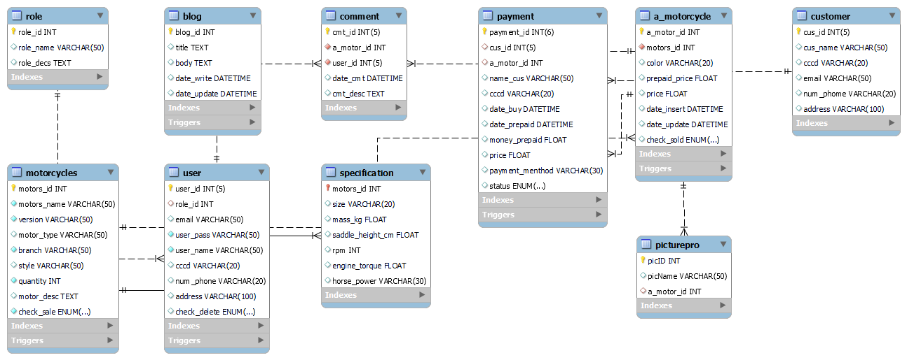

**V. DESIGN WEBSITE**

**1. Front-end design**

**1.1. Login form**

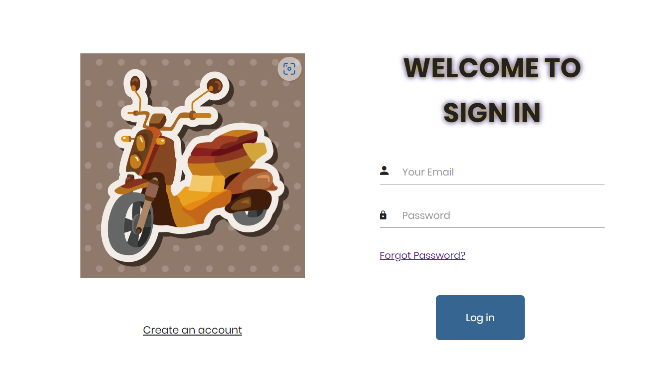

*Figure 7. Login form*

|  |
| --- |
|  |
| *Figure 8. Sign up form* |

**1.2. Shop page**

|  |
| --- |
| D:\Download\Trang chủ\chu1.PNG |
| D:\Download\Trang chủ\chu2.PNG |
| D:\Download\Trang chủ\chu3.PNG |
| *Figure 9. Home page form* |

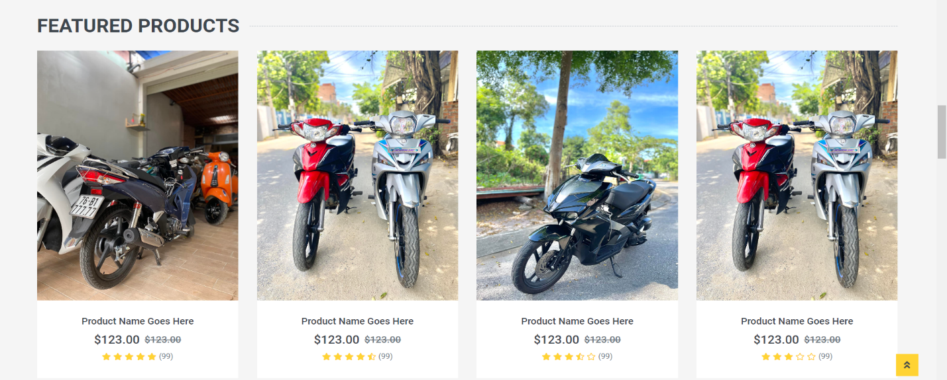

# *Figure 10. Main page*

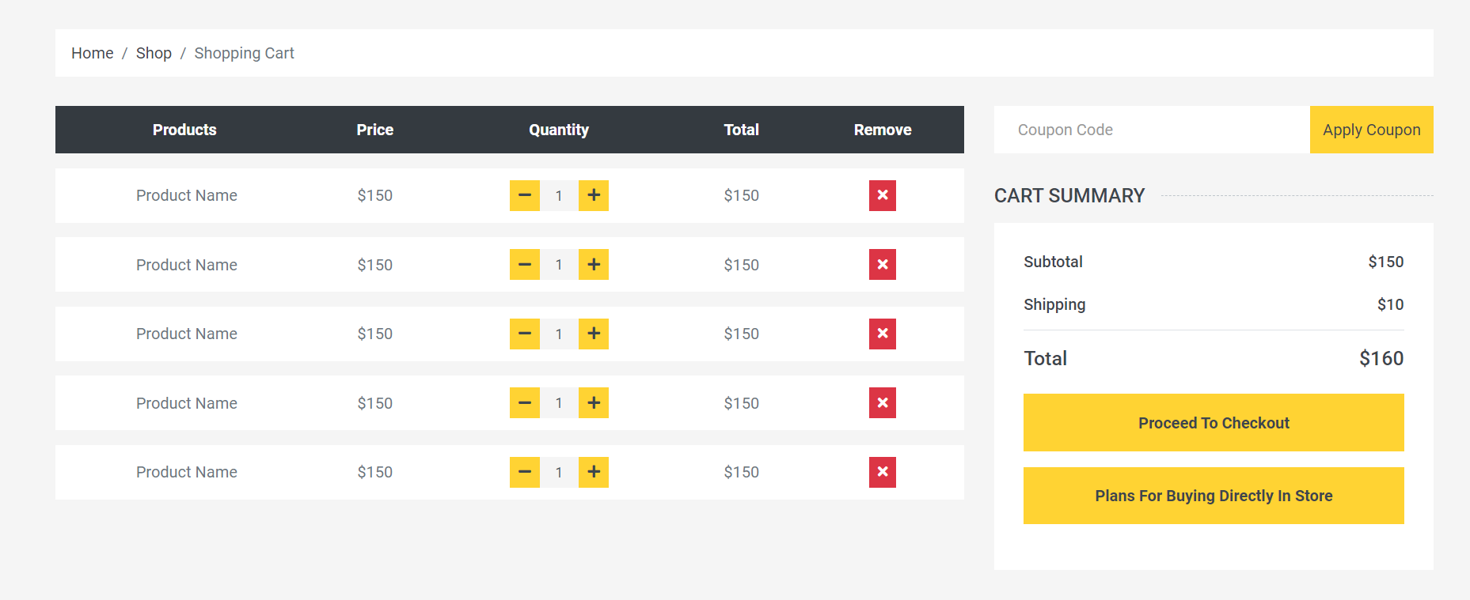

# *Figure 11. Shopping cart form*

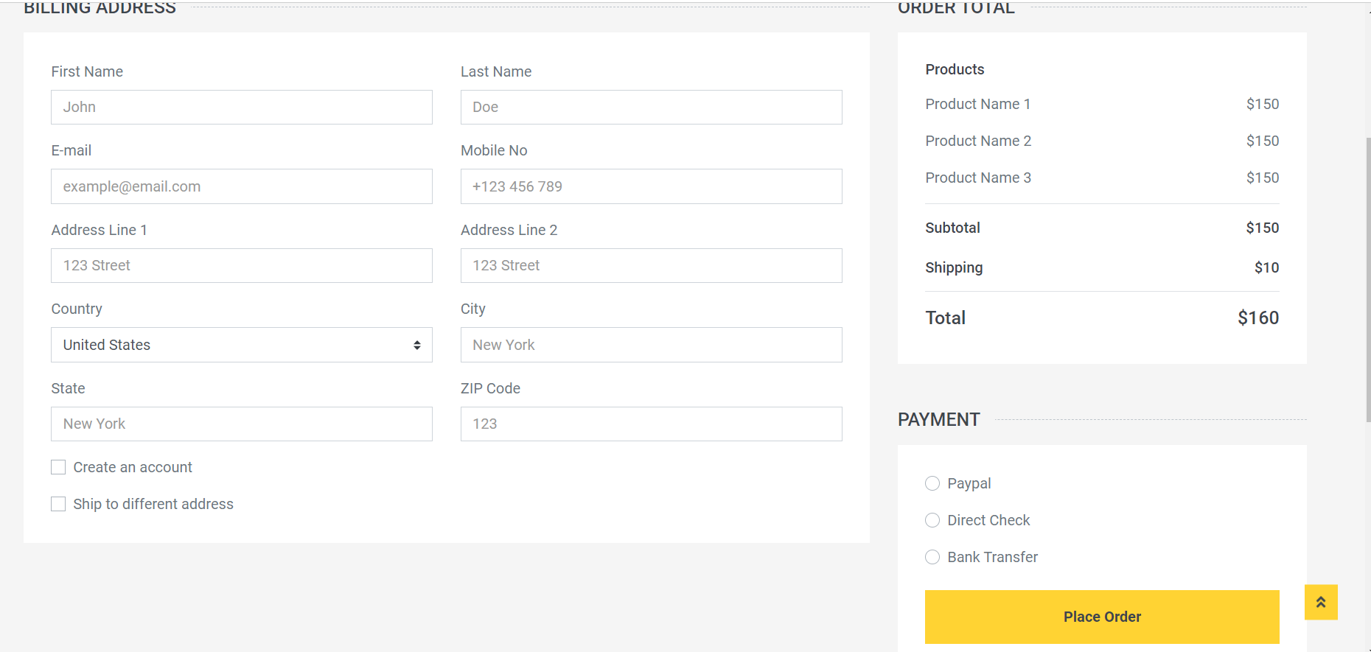

# *Figure 12. Check out form*

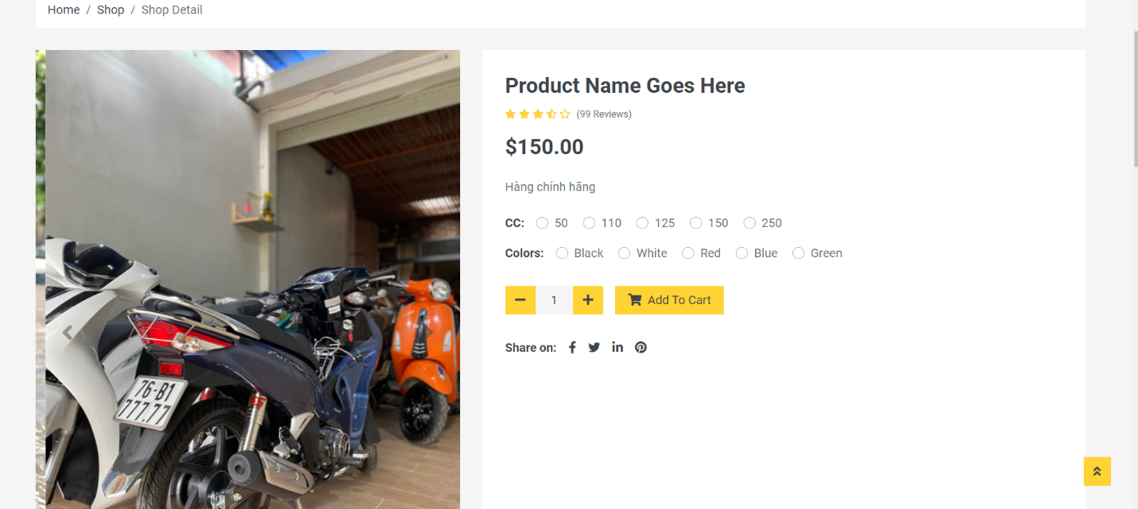

# *Figure 13. Shop detail form*

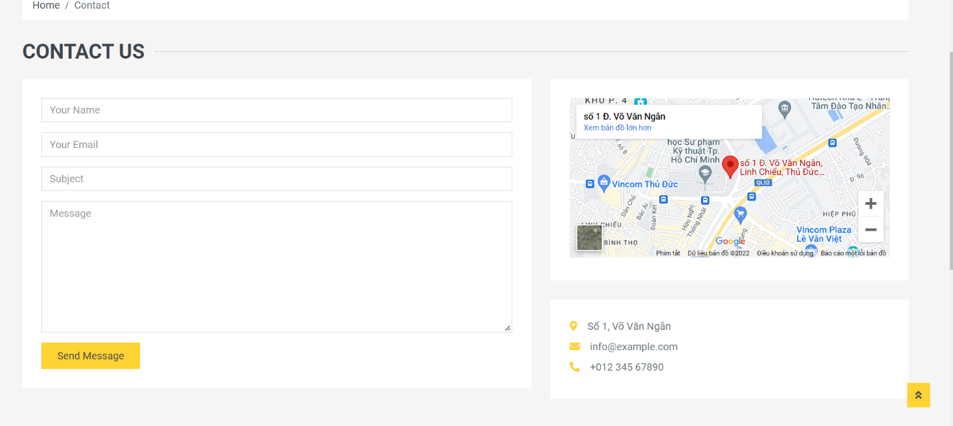

# *Figure 14. Contact form*

**1.3. Admin page**

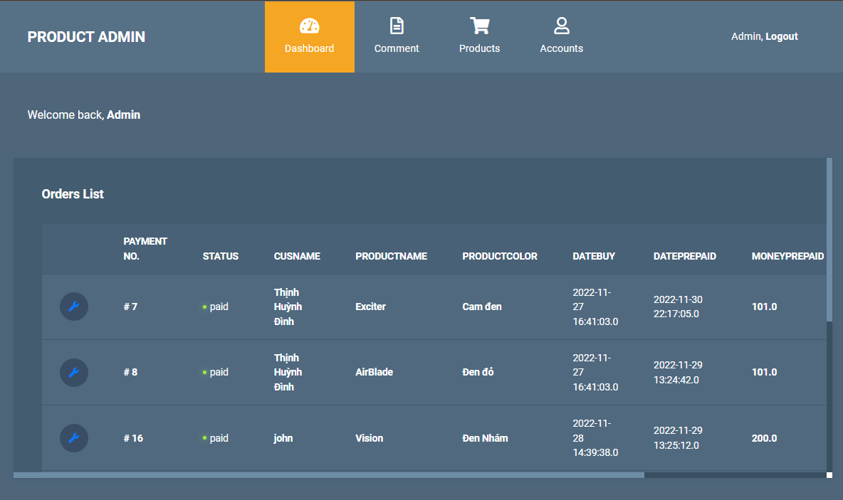

# *Figure 14. Admin form payment*

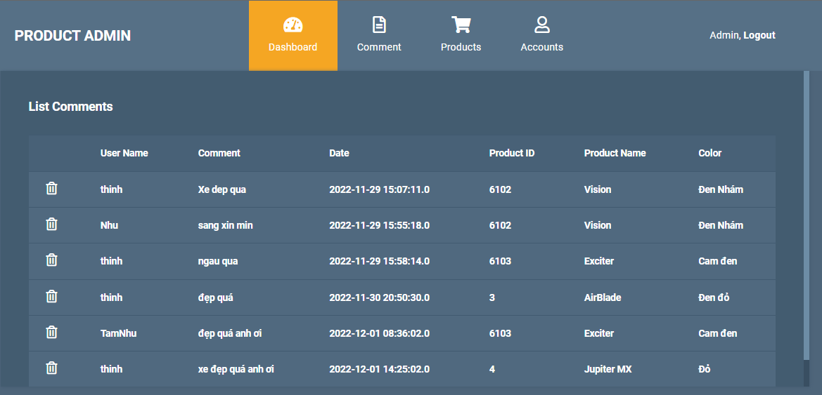

# *Figure 15. Admin form comment*

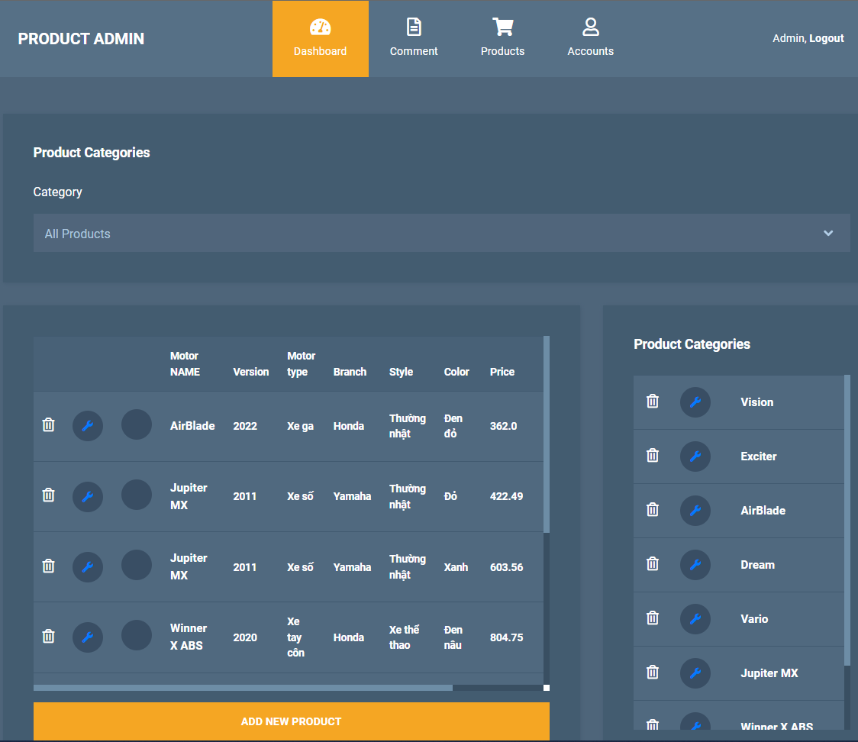

# *Figure 16. Admin form product categories*

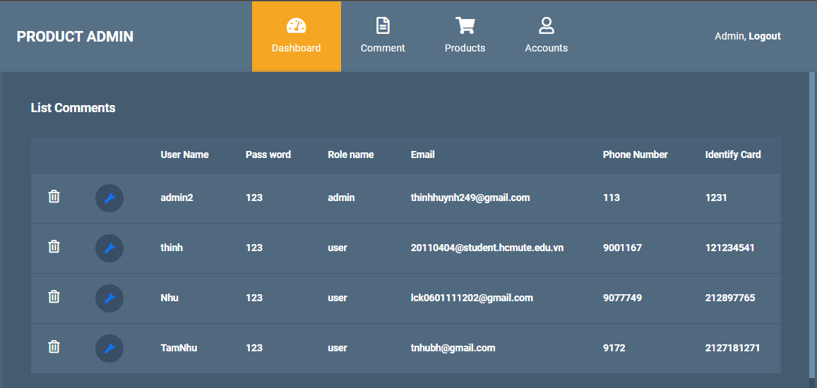

# *Figure 17. Admin form account*

**2. Back-end design**

**2.1. Architecture**

*- Presentation Layer:*

Receive requests for data in and save it down to the data access layer through the layer to the database. Return the response processed by the Service layer functions to the client or return some views or return the rest API (message or code,...).

*- Business logic:* After executing the query, get the data from the DAO layer and this layer will handle the logic on which the function will operate.

*- Data AccessLayer:* Contains queries used to query data from database

*- Database:* MySQL

**2.2. Directory structure**

*- API /Controller:*

The API is actually just a controller, but its functions and tasks of adding, deleting, and editing will be done by separate functions.

Here using the restful API to receive data from the client in the form of json and convert it to a string and then map with the fields in the Service's function call model to handle what to do.

then get back the processing result from the Service and map back the data from the model's fields to a string then convert it to json and return it to the client .

The handling of converting json to string is done by the of function of the HttpUtils class. The string mapping with the model fields is taken care of by the toModel function of the HttpUtils class.

*- Service layer*

There are 2 components, the interface and the class that implements that interface. The reason for including 2 components is because it is necessary to ensure the D property in SOLID.

This service layer will handle the necessary logic to add, delete, edit, search thanks to the results returned by the DAO layer.

*- DAO layer:*

There are 2 components, the interface and the class that implements that interface. In the interface there will be a parent interface GenericDAO that declares common functions for the DAO layer such as query (used for select), insert, update (used for both update and delete).

**3. Code functions of website**

**3.1. Functions for adding, deleting, editing, select. (Data Access Layer)**

**- Interface GenericDAO**

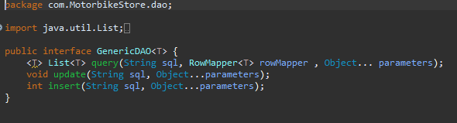

*Figure 19. Interface GenericDAO*

*Class abstractDAO implements Interface GenericDAO*

|  |
| --- |
|  |
| *Figure 20. Function getConnection (connect database)* |

|  |
| --- |
|  |

*Figure 21. Function query*

|  |
| --- |
|  |
| *Figure 22. Function setParameter* |

|  |
| --- |
|  |
| *Figure 23. Function update* |

|  |
| --- |
|  |
| *Figure 24. Function insert* |

**3.2. Function for each special functions**

**3.2.1. Login, regist, forget password**

*- View layer*

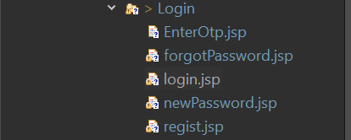

*- Controller layer*

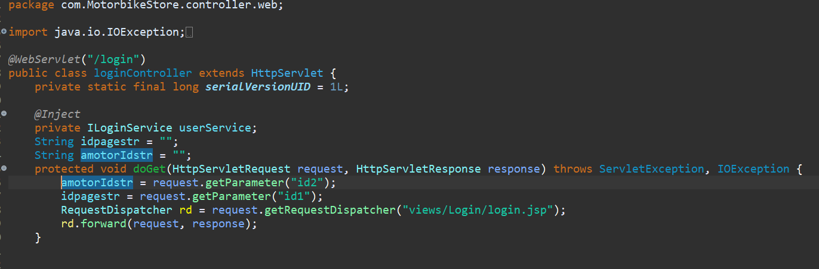

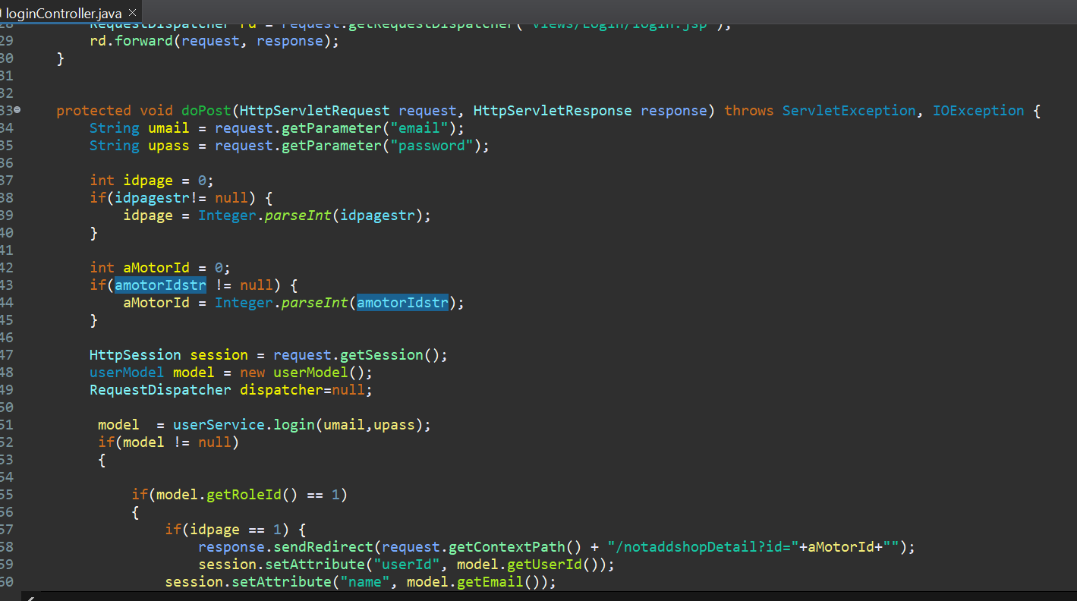

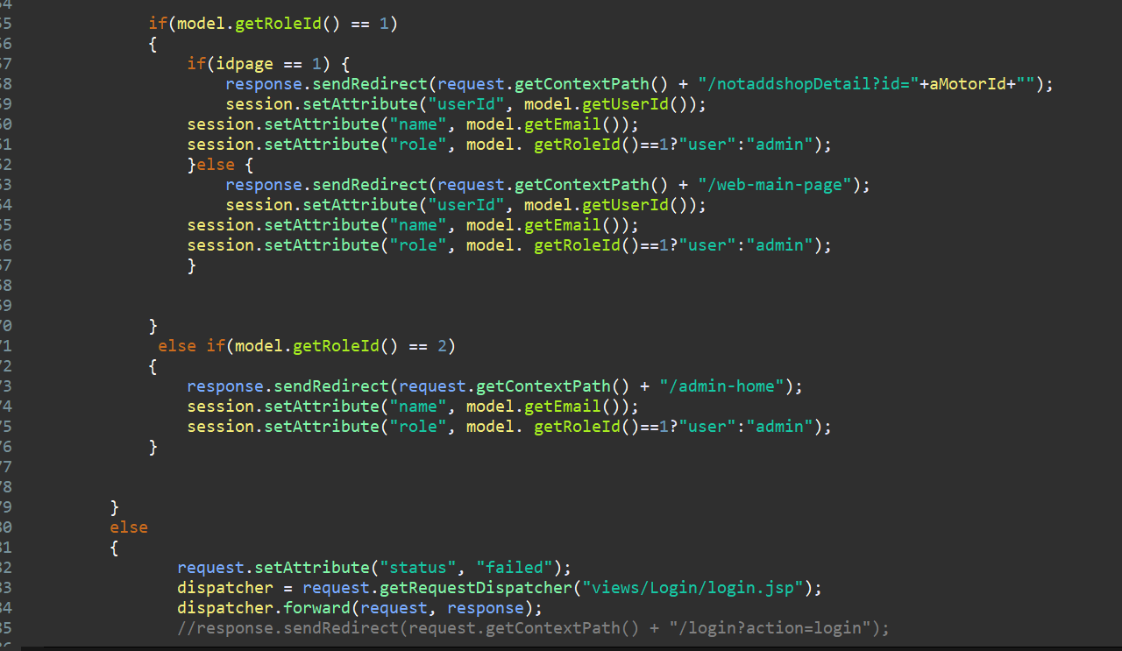

*- DAO layer*

*- Model layer*

**3.2.2. Insert, delete, update, upload pictures for products**

* ***Insert product***

*- View layer*

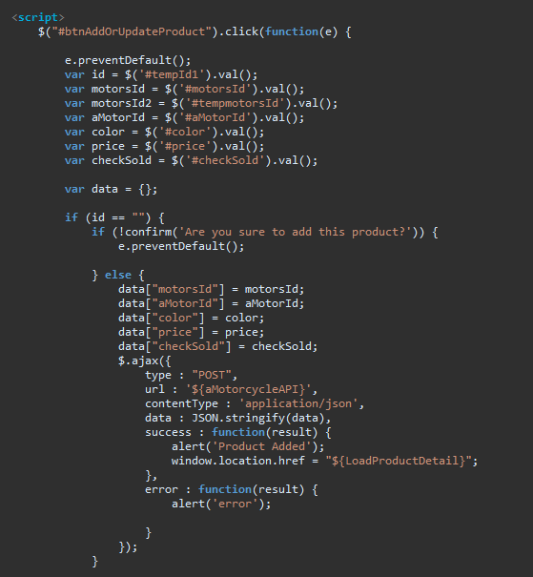

*- API layer:*

|  |
| --- |
|  |
|  |

*- Service layer:*

|  |
| --- |
|  |
|  |

*- DAO layer:*

|  |
| --- |
|  |
|  |

* ***Update product***

*- View layer:*

|  |
| --- |
|  |
|  |

*- API layer:*

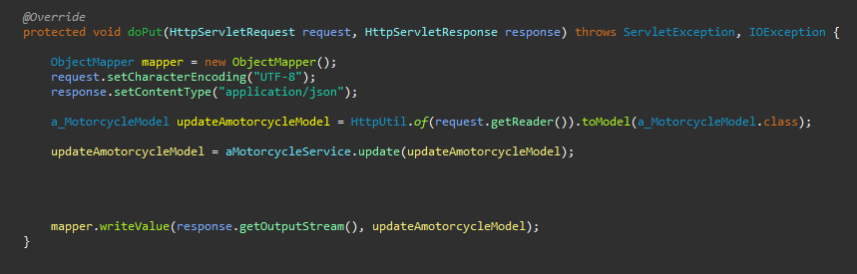

*- Service layer:*

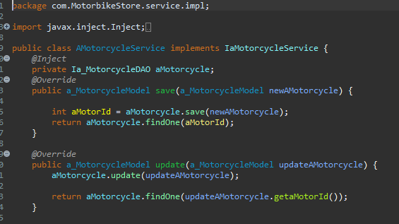

*- DAO service:*

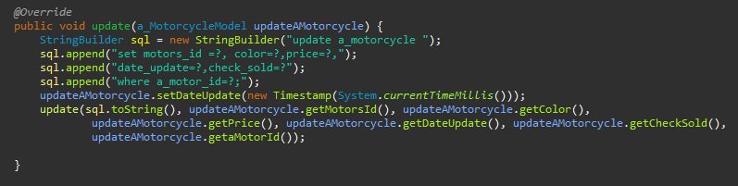

* ***Delete product:***

*- View layer****:***

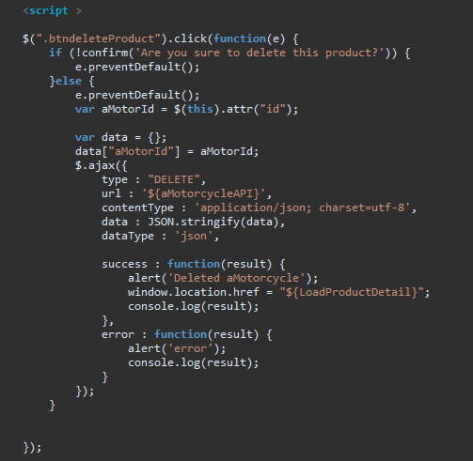

*- API layer:*

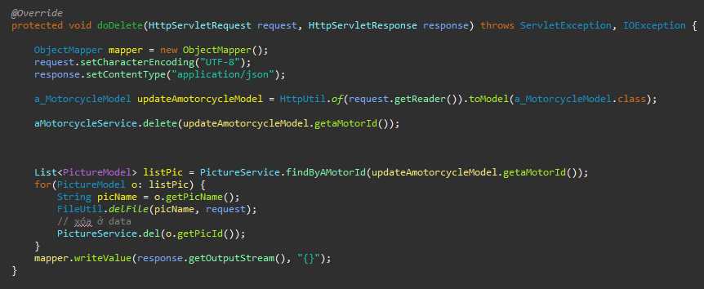

*- Service layer:*

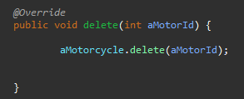

*- DAO layer:*

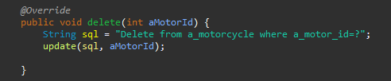

**3.2.3. Search product based-on their name**

*- UI layer*

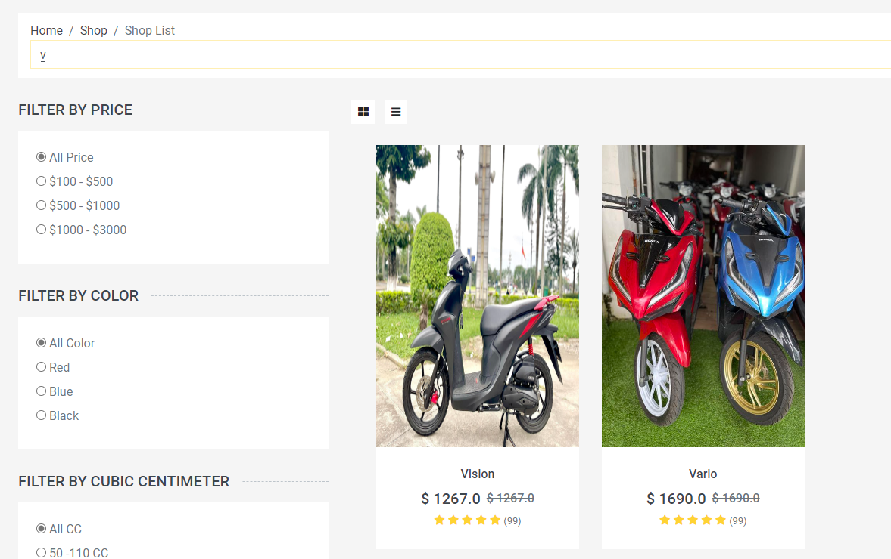

- View layer:

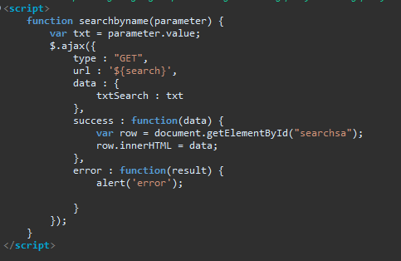

- Controller layer:

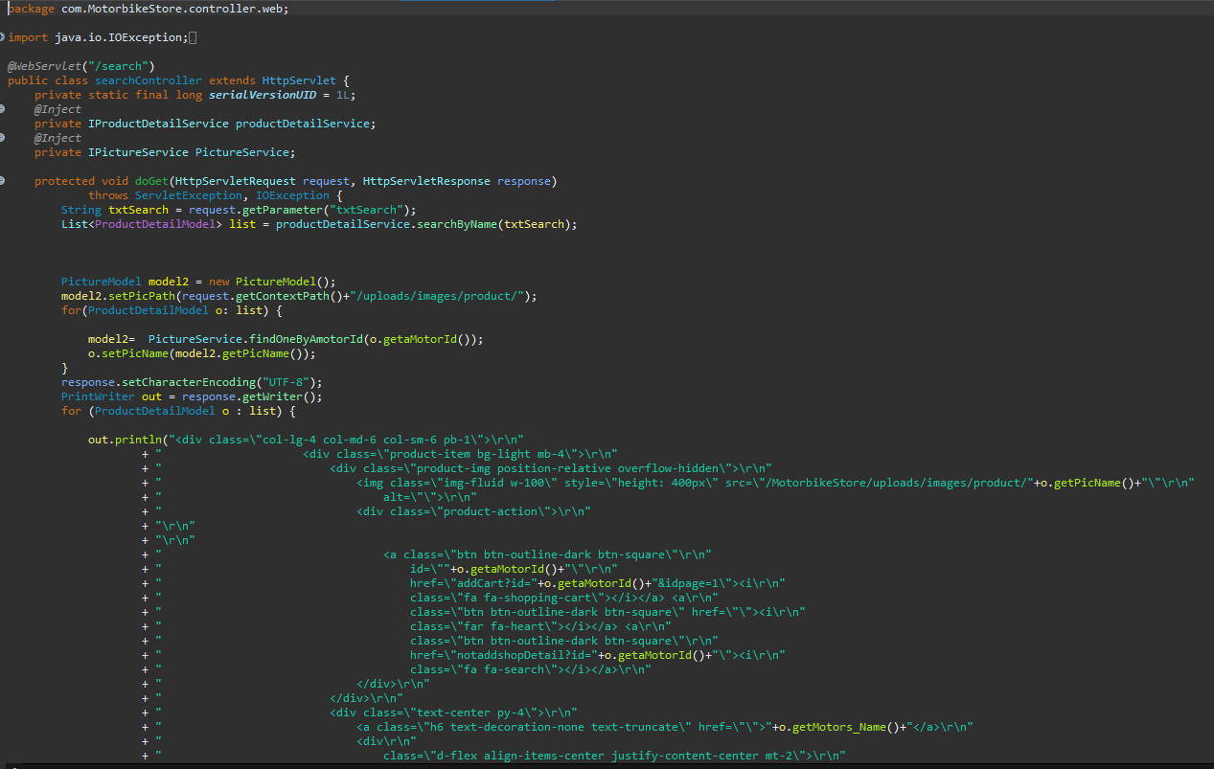

- Serice layer:

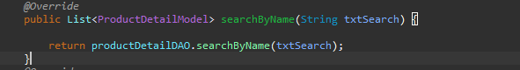

*- DAO layer:*

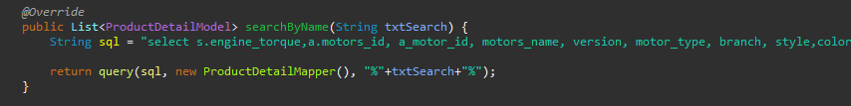

**3.2.4. Filter based-on price, color, cubic centimeter**

*- UI layer*

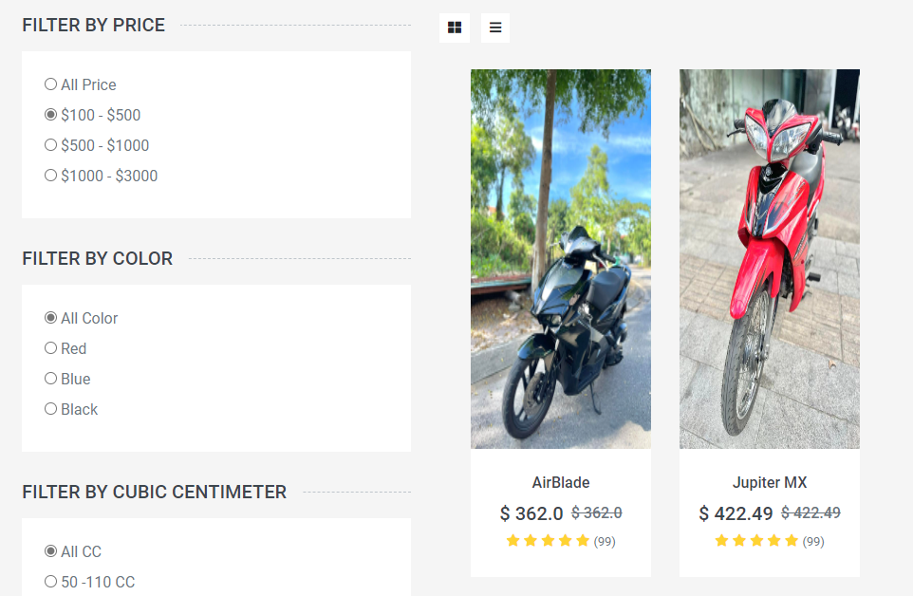

*- View layer*

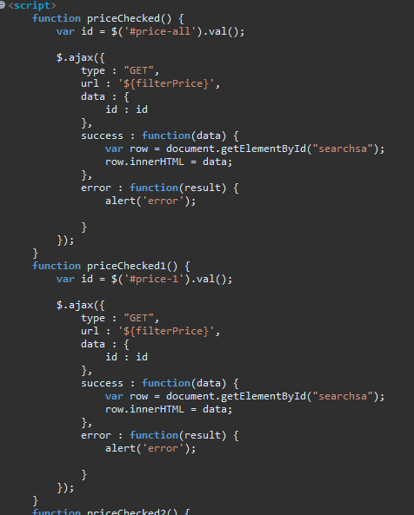

*- Controller layer:*

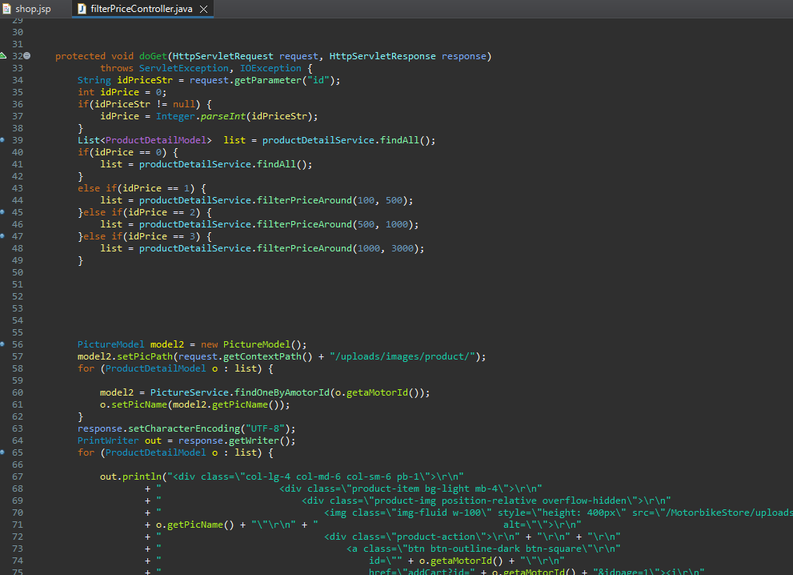

*- Service layer:*

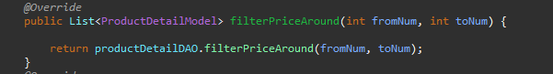

*- DAO layer:*



**3.2.5. Cookie for cart**

*- UI layer:*

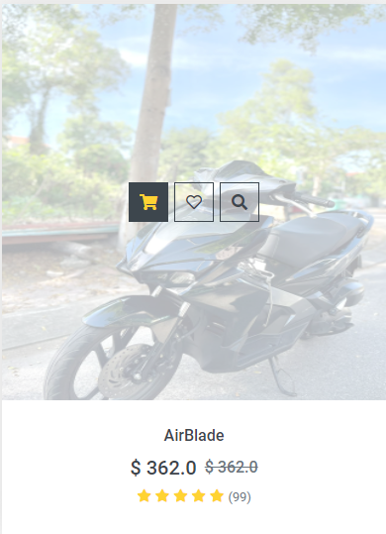

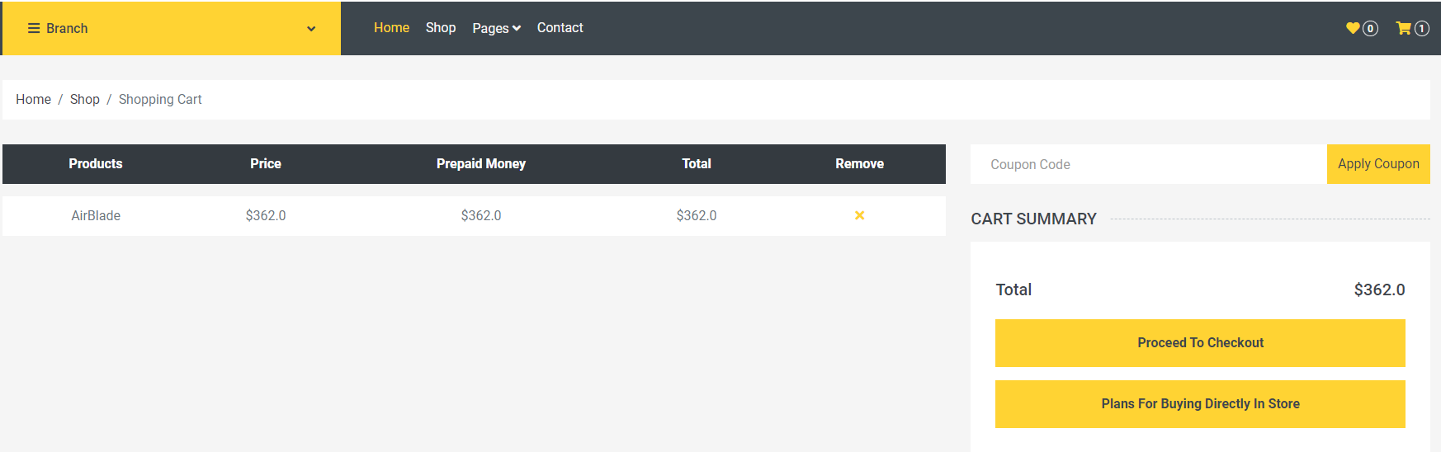

*- Controller layer:*

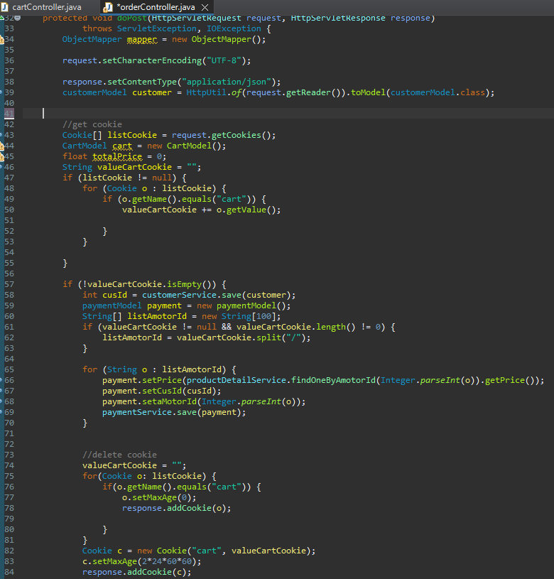

**3.2.6. Comments and product reviews**

*- UI layer:*

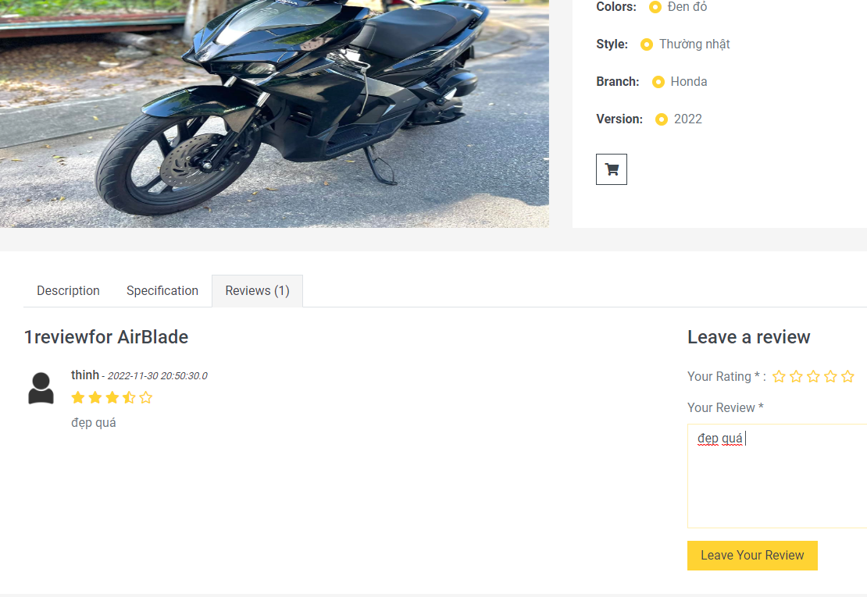

*- Controller layer:*

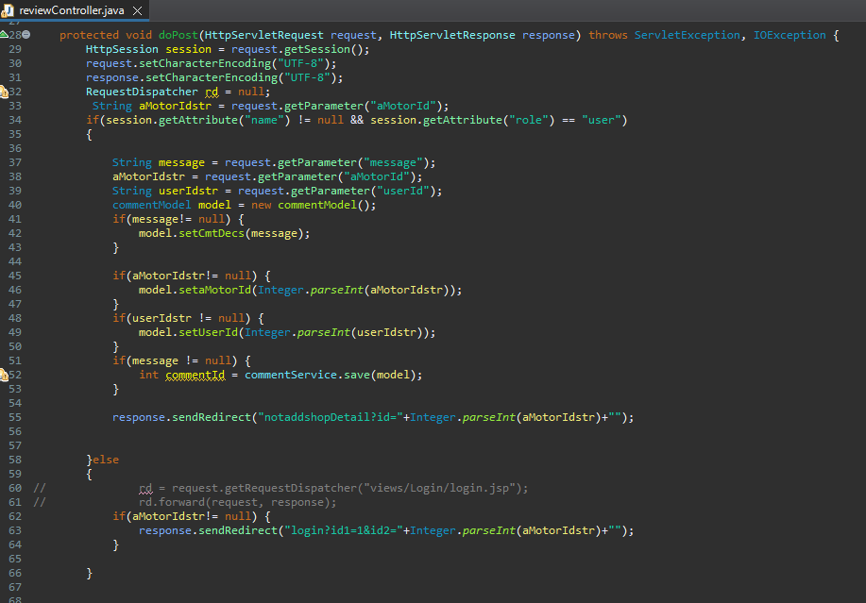

*- Model layer:*

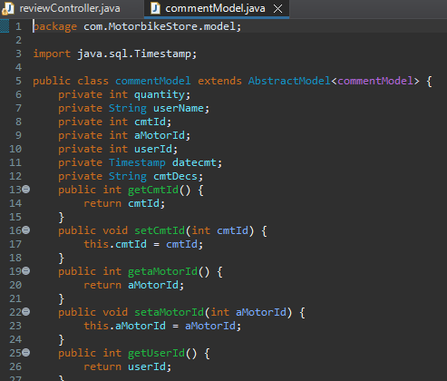

*- Service layer:*

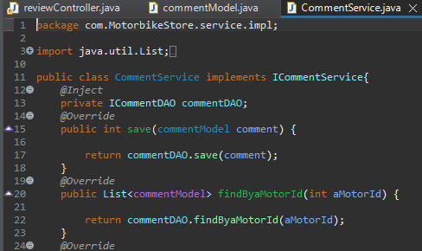

*- DAO layer:*

